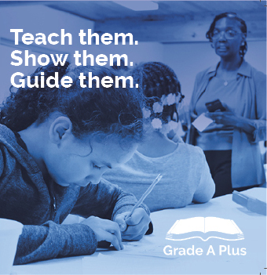
Dec. 1 – 31, 2019
See the link below to give your financial support!
Your COMOGIVES contribution will help us accomplish the goals listed below in 2020!

https://comogives.com/product/ grade-a-plus-3/

Grade A Plus is growing! In 2020, with your contribution Grade A Plus intends to:
- maintain no more than a 1:2 ratio for tutor to student pairings
- maintain transportation time to less than 30 minutes per van trip
- increase personal communication and support for family leaders
- increase the marketing and data collection teams
- increase outreach into the community and opportunity for more community participation.

Follow us on Facebook: https://www.facebook.com/GradeAProgram/
Visit the Website: www.gradeaplusinc.com
See the Video on YouTube: https://www.youtube.com/watch?v=6wkeoWd1Xo8&t=1s

You’re Invited! Come and Celebrate
with us!
Thursday, Dec. 12th, 2019
Anytime between 4:30 and 7p.m!
310 Tiger Lane, Suite 202A
Call or Text 573-268-4372 to let us know you are stopping in for a light refreshment.

You can also stop in to drop off a paper contribution or get help with making an on line contribution to the COMOGIVES campaign.

